Database Languages & Interfaces

* A DBMS has appropriate languages and interfaces to express database queries and updates.

Types of Database Language

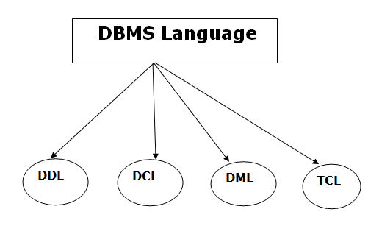

1. Data Definition Language

* **DDL** stands for **D**ata **D**efinition **L**anguage. It is used to define database structure or pattern.
* It is used to create schema, tables, indexes, constraints, etc. in the database.
* Using the DDL statements, you can create the skeleton of the database.
* Data definition language is used to store the information of metadata like the number of tables and schemas, their names, indexes, columns in each table, constraints, etc.

Here are some tasks that come under DDL:

* **Create:** It is used to create objects in the database.
* **Alter:** It is used to alter the structure of the database.
* **Drop:** It is used to delete objects from the database.

**Difference between Drop and Truncate**

**Truncate:** It is used to remove all records from a table.

2. Data Manipulation Language

**DML** stands for **D**ata **M**anipulation **L**anguage. It is used for accessing and manipulating data in a database. It handles user requests.

Here are some tasks that come under DML:

5

* **Select:** It is used to retrieve data from a database.
* **Insert:** It is used to insert data into a table.
* **Update:** It is used to update existing data within a table.
* **Delete:** It is used to delete all records from a table.

3. Data Control Language

**DCL** stands for **D**ata **C**ontrol **L**anguage.

Here are some tasks that come under DCL:

* **Grant:** It is used to give user access privileges to a database.
* **Revoke:** It is used to take back permissions from the user.

4. Transaction Control Language

TCL is used to run the changes made by the DML statement.

**Commit:** It is used to save the transaction on the database.

**Rollback:** It is used to restore the database to original since the last Commit.

# Interfaces in DBMS

***************************************

A database management system (DBMS) interface is a user interface that allows for the ability to input queries to a database without using the query language itself.

**1.Menu-Based Interfaces for Web Clients or Browsing**

**2.** **Forms-Based Interfaces**

**3.** **Graphical User Interface**

**4.** **Natural language Interfaces**

**5.** **Speech Input and Output etc..**